## <https://www.overleaf.com/5518756513tcjsvtrsrdyc>

## Bays:

Z1 Gate distances

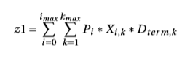 P = passengers. X=decision variable, D=distance i to k

Z2 Gate preferences

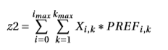

z4=a*z1+b*z2

z5=a*z1+b*z2+g*z3

z3=combo of penalty values U,V,W

U = towing from set arrival bay to the night parking bay

V, W = towing from parking to departing bay for night stays, and towings for non night stays.

## Gates

Z6 Minimization of distance between bay and gate



Z7 Maximization of airline preferences

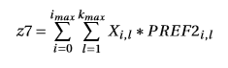

Z8 Sum of all penalty values M



**Gate constraints.**.

Linking DOM flights to DOM gates and non to non

Domestic flights gate 1 or 2 only.  
Sum of all domestic flights over gates 1 and 2 should be equal to one. All other flights should be equal to zero. This leads to eq 5.15 and 5.16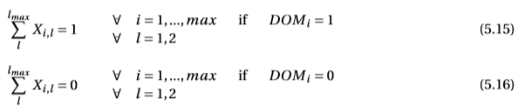

KQ handled flights can be separated easily due to the bay assignment separation groups. Another division needs to be made between flights before and after 6pm. => if statement that only loads flights with a departure time after 6pm. These flights are then blocked from terminal B and C, consisting of gates 4,5,7,8,9,10. i represents all departing KQ flights after 6pm.

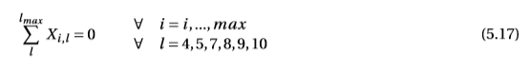

**Bay constraints**

* Only 1 aircraft at a bay at a given time. The basic idea is that for every time slot at every bay all flights that are compatible with that bay and are within the slot will be summed up. Since not every bay should be occupied every time slot the summation should be less or equal then 1. T is the compliance matrix that shows what aircraft do not conflict (i cannot be equal to j since an aircraft always conflicts with itself per definition).

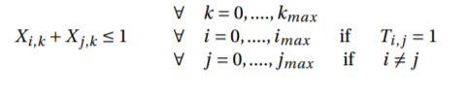

* Bay compliance constraint. Each aircraft is only assigned to a bay it is compliant with. B is the compliance matrix

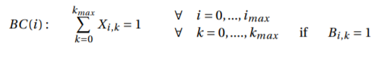

* Single bay per aircraft constraint, only one allowed per aircraft

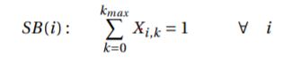

* Fueling constraint. All aircraft that require fueling are placed at a bay where fueling is possible. Only relevant for departing flights. For all non-domestic flights and “full domestic flights”:

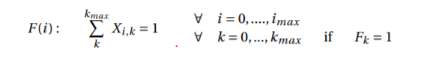

For long stay domestic departing flights: (Optional)

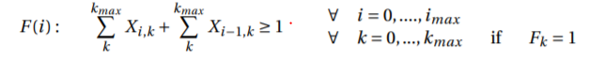

* Splitted Flight Constraints (Optional)



* Adjacency Constraints



Robust scheduling models:

Robust measures => Safety factors

Buffer times => 15 minutes added before arrival, 15 minutes after arrival

Robust optimization => For every delay scenario a number of M penalty values exist, equal to the length of the amount of additional time constraints. Delay scenarios are randomly generated based on historical data. Basically, when the time matrix from the baseline schedule equals zero and in the new scenario equals one there is a new conﬂict to design for and this is then added as new constraint with penalty value.

To provide a feasible and valuable solution a minimum buffer time is used in combination with the new objective function. This buffer time is based on the minimum buffer time used at JKIA of 10 minutes.

Spare bays => use of spare bays has a positive effect on delays. Bays J2A and J2B are assumed to be unavailable. (capacity altered from 0 to 1)